# **3. Methods**

## *3.1 North Wyke tracking data (ATLAS system)*

## We used high temporo-spatial tracking data collected as part of other studies (e.g. Beardsworth et al. 2021, Heathcote et al. 2023) using the ATLAS reverse GPS system (described and validated in Beardsworth et al. 2022). The system included four receiver stations positioned at high points in the landscape surrounding the North Wyke Research Farm release site (latitude: 50.772022, longitude: -3.901460). One hundred and twenty-five ~10 weeks old pheasants that had been reared by humans, similar to commercial game rearing practices, were equipped with backpack tags (22g) and released into a woodland pen. The tags transmitted signals at ¼ Hz. We decimated these to a rate of XX and derived mean/median locations to improve spatial accuracy. Tracking occurred from July 2018 to XXX 2019, and the accuracy and precision of the collected data were evaluated (Beardsworth 2019). The fix rate in this dataset is approximately every 5 minutes, however this data was subsampled to hourly fixes to match the fix rate of the rest of the tracking data.

## *3.2 APHA data*

???

## *3.3 Step length and turning angle.*

The distance moved between one location fix and the next was calculated in meters for both sets of tracking data; we henceforth refer to this as the step length. These step lengths were then modelled using a gamma distribution. This allowed us to find the shape and rate parameters that had the highest likelihood of generating the step lengths observed.

The relative angle between a step and the previous step was also calculated. This was calculated in radians, where a value close to zero indicates an individual continued in a similar direction from one step to the next (low path tortuosity). A value close to ±π indicates an individual turned back on itself from one step to the next (high path tortuosity); we henceforth refer to this as the turning angle. These turning angles were then modelled using a Von Mises distribution (a circular distribution with a location parameter and a concentration parameter). This allowed us to find the parameter set that had the highest likelihood of generating the turning angles observed. These models were run in R (version 4.4.0; R Core Team, 2021) and RStudio (version 2024.09.0; RStudio Team, 2020) using the *brms* package (version 2.21.0; Bürkner, 2021). The median posterior values were extracted from each of these models to be used in the simulation, as propagating uncertainty from these models was too computationally intensive.

## *3.4 Integrated step selection function*

We use an integrated step selection function (iSSF) approach (Avgar *et al*., 2015) to analyse preferences or aversions the pheasants may have to a set of external covariates. These models assume that an animal *could* move anywhere given the distribution of step lengths and turning angles per fix rate. These models also assume that where an animal *chooses* to move is dictated by its preference (or aversion) for aspects of that spatial location (for example, habitat type). By comparing the possible steps an animal could have taken (known as control steps) and the actual observed steps an animal took, we can determine how spatial covariates affect an animal’s probability of taking a step, and therefore their preference or aversion to those covariates. In an integrated step selection analysis, we also control for the effects that step length magnitude and turning angle have on the probability that a step is taken (Avgar *et al*., 2015).

The covariates we included in this model were the distance to release pen (number of meters to the edge of the release pen) and distance to hopper feeders (number of meters to the coordinates recorded for hopper feeder sites), which were calculated using the distance function in the *terra* package (version 1.7-78; Hijmans 2024). We also included an interaction between distance to release pen and time since release. This interaction was included as we have *a priori* evidence that the pheasant’s preference for being in and around the release pen declines over time after release (Hill & Ridley, 1987). We also investigated the effect of habitat type, defined as one of the 10 aggregate classes extracted from the United Kingdom Centre for Ecology and Hydrology’s (UKCEH) 2021 Land Cover map (Marston *et al*., 2022), as well as distance to the nearest woodland (also extracted from the UKCEH 2021 Land Cover map). Also included as covariates in these models were the step length, log of the step length, and cosine of the turning angle (Avgar *et al*., 2015).

### *3.5 Data simulation*

#### 3.5.1 Simulation parameters

The pheasant dispersal simulation was run using X groups of N individuals (XN total individuals). Each discrete time step in the model corresponded to XX hours so as to match the fix rate in the tracking data. The date and time at which the simulation begins was 07:00 on 18th July, as this matched when tags were deployed in the APHA tracking dataset. The dispersal simulation ended at the end of the following February, as after this date we have less tracking data (due to mortality and dispersal) and therefore less confidence in pheasant dispersal patterns.

Hereafter, we refer to pheasants in the model as agents, to distinguish their behaviour from that of real birds. The model was written in R and uses the *terra* package (Hijmans 2024) and the *sf* package (version 1.0-16; Pebesma, 2018, Pebesma & Bivand, 2023). The code for the simulation can be found at XXX.

The area in which we simulate pheasant dispersal is limited to a 20km x 20km square centred around the centre of the release pen. The simulation area was limited to this to reduce computational load, yet allow agents enough room to disperse up to the distances we observe in the tracking data; the maximum distance a pheasant dispersed from the release pen during the tracking period was XX km.

#### 3.5.2 Dogging-in

At managed gamebird release sites, gamekeepers take steps in order to attempt to return pheasants to the release pen. These efforts usually involve patrolling the shooting area on a daily basis, usually in the evening, with a dog in order to herd dispersed birds back towards the release pen (“dogging-in”; GCT 1996). To capture these efforts in our dispersal simulation, we include stochastic herding. In the simulation, if an agent is located outside the release pen but within X metres between the hours of XXX and XXX during the first X months since release, there is a P probability that that agent is returned to the release pen for the night and a 1-P probability that the agent is herded to the nearest location that is X metres away from the release pen. This is to capture the possibility that pheasants are accidentally moved further away from the release pen when gamekeepers are dogging in.

#### 3.5.3 Mortality

To reflect the seasonally dependent mortality rates in released pheasants, we include a season-specific daily mortality rate for agents in the simulation. At the start of each day in the simulation, there is a probability that an agent dies, and their dispersal ceases to be simulated. These probabilities are based on the findings of Madden, Hall & Whiteside (2018), who show that approximately 47% of released pheasants survive autumn (1st August – 1st November), 36% of remaining pheasants survive winter (1st November – 1st April), and 36% of remaining birds survive until the following autumn (1st April – 1 August). To reflect these mortality rates, there is a daily probability of mortality of $1-{0.47}^{\left(\frac{1}{92}\right)}= 0.0081…$ in autumn (92 being the number of days from 1st August – 1st November), and a daily probability of mortality of $1-{0.36}^{\left(\frac{1}{151}\right)}= 0.0067…$ in the winter (151 being the number of days from 1st November – 1st April). Due to these mortality probabilities, approximately 16% of agents survive until 1st April, which closely matches observed data (Madden, Hall & Whiteside, 2018).

#### 3.5.4 Diurnal movement

In the simulation, each time step was classified as either day or night based on whether it falls between sunrise and sunset (day), or between sunset and sunrise (night). Sunset and sunrise times were calculated based on the location of the release pen for the North Wyke tracking data and the date of each time step using the *suncalc* package (version 0.5.1; Thieurmel & Elmarhraoui, 2022) in R.

To begin the simulation, an agent is assigned a random initial location within the release pen. From this initial location, 250 step lengths and turning angles are drawn from the distributions described in section 3.3 to make 250 control steps (possible steps which an agent can take between one time step and the next). The step weight for each of the control steps is then calculated using the values of the covariates at each of the resultant control locations. The covariates used to calculate step weights are those used in the iSSF outlined in section 3.4. These step weights are then converted to probabilities based on the following equation

$$P\left(s_{t+1}=i\right)=\frac{{\left(e^{\sum_{n=1}^{N}{β_{n}x_{n}}}\right)}_{i}}{\sum_{j=1}^{J}{{\left(e^{\sum_{n=1}^{N}{β_{n}x_{n}}}\right)}_{j}}}$$

where P(*s­t+1= i*) is the probability of taking the *i*th control step between time *t* and *t+1*, *N* is the total number of covariates used in the iSSF, *βn* is the coefficient of the effect of the *n*th covariate *xn­* on pheasant movement, *J* is the total number of control steps drawn from the step length and turning angle distributions. Given each control step has been assigned a step probability based on the features of the new location at time *t+1*, we now stochastically select a control step using these probabilities. The selected step is taken, and the resultant location is recorded as the agent’s location 1 hour after the previous location (this temporal resolution is used to match the fix rate from the GPS tracking data). This diurnal movement process is then repeated until a time of day when dogging in occurs (and the agent is within the dogging-in buffer), or until after sunset.

#### 3.5.5 Nocturnal movement

To reflect the propensity of pheasants to roost in wooded areas of which they have some experience (Hill & Robertson 1986), the agents in the simulation move to the nearest woodland area that they have explored during daytime in the simulation up until the current time point. We achieve this by taking all diurnal location fixes for an agent up until the current time point and calculating a XX% kernel density estimate (KDE). We then propose 250 control steps that could be taken from the current location using the same process described in section 3.5.4. The agent then takes the control step that results in a location closest to the nearest woodland within the XX% KDE of diurnal location fixes (assuming they are not already within woodland within the XX% KDE). This process is then repeated until the agent is within woodland within the XX% KDE, at which point it is assumed to be at roost and the location is kept the same until sunrise, when the diurnal movement process in section 3.5.4 begins again.

If an agent happens to be within woodland that falls within the XX% KDE when night begins, the agent is assumed to be at roost at that location and will remain stationary until morning the following day.

#### 3.5.6 Ending the simulation.

The simulation for each agent ends either when an agent dies due to mortality probabilities (section 3.5.3), an agent moves further than 10km away from the release pen (which we count as ‘out of tracking range’), or an agent reaches midnight on 28th February, after which the simulation ends.

# **4. Results**

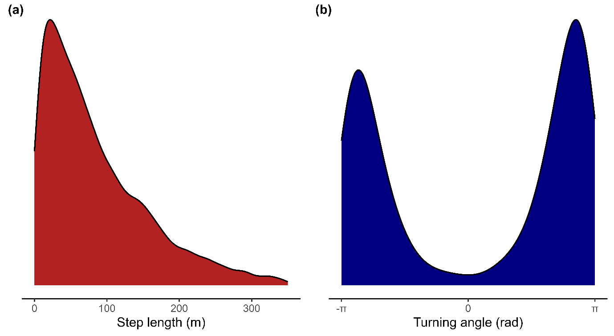

Figure 1- density plots showing the distribution of step lengths (a) and turning angles (b) from the tracking data. The fix rate in the tracking data was one fix per hour.[could go in supp mat?]

## 4.1 Step length and turning angle

The mean of the gamma distribution describing the distance a pheasant moves between one fix and the next (one hour later) was 90.95 meters ($e^{4.15}$) and the shape parameter was 1.15. The distribution of step lengths used in the model is shown in figure 1a.

The mean of the Von Mises distribution describing the relative angle between one location fix and another (one hour later) was 3.02 radians, suggesting that the tracked pheasants on average had high path tortuosity, often turning back and retracing previous paths taken. The concentration parameter of the Von Mises distribution was 1.79. The distribution of turning angles used in the model is shown in figure 1b.

## 4.2 Integrated step selection function

# **References**

Avgar, T., Potts J. R., Lewis, M. A., Boyce, M. S. (2015). Integrated step selection analysis: bridging the gap between resource selection and animal movement. *Methods in Ecology and Evolution*, 7, 619-630. <https://doi.org/10.1111/2041-210X.12528>

Beardsworth, C. E. (2019). *Exploring the relationship between spatial cognitive ability and movement ecology*. University of Exeter (United Kingdom).

Beardsworth, C. E., Whiteside, M. A., Capstick, L. A., Laker, P. R., Langley, E. J., Nathan, R., Orchan, Y., Toledo, S., van Horik, J. O., Madden, J. R. (2021). Spatial cognitive ability is associated with transitory movement speed but not straightness during the early stages of exploration. *Royal Society Open Science*, 8, 201758. <https://doi.org/10.1098/rsos.201758>

Beardsworth, C. E., Gobbens, E., van Maarseveen, F., Denissen, B., Dekinga, A., Nathan, R., Toledo, S., Bijleveld, A. I. (2022). Validating ATLAS: A regional-scale high-throughput tracking system. *Methods in Ecology and Evolution*, 13, 1990-2004. <https://doi.org/10.1111/2041-210X.13913>

Bürkner P (2021). Bayesian Item Response Modeling in R with brms and Stan. *Journal of Statistical Software*, 100, 1–54. <https://doi.org/10.18637/jss.v100.i05>

GCT (1996) *Gamebird Releasing*. The Game conservancy trust, Fordingbridge, UK

Hijmans, R. (2024). *terra*: Spatial Data Analysis. R package version 1.7-78, <https://CRAN.R-project.org/package=terra>

Hill, D. A., Ridley, M. W. (1987). Sexual segregation in winter, spring dispersal and habitat use in the pheasant (*Phasianus colchicus*). *Journal of Zoology*, 212, 657-668. <https://doi.org/10.1111/j.1469-7998.1987.tb05962.x>

Madden, J. R., Perkins, S. E. (2017). Why did the pheasant cross the road? Long-term road mortality patterns in relation to management changes. *Royal Society Open Science*, 4, 170617. <http://doi.org/10.1098/rsos.170617>

Madden, J. R., Hall, A., Whiteside, M. A. (2018). Why do many pheasants released in the UK die, and how can we best reduce their natural mortality? *European Journal of Wildlife Research*, 64. <https://doi.org/10.1007/s10344-018-1199-5>

Marston, C., Rowland, C.S., O’Neil, A.W., Morton, R.D. (2022). Land Cover Map 2021 (25m rasterised land parcels, GB). NERC EDS Environmental Information Data Centre. <https://doi.org/10.5285/a1f85307-cad7-4e32-a445-84410efdfa70>

Pebesma, E., Bivand, R. (2023)*. Spatial Data Science: With Applications in R*. Chapman and Hall/CRC. <https://doi.org/10.1201/9780429459016>

Pebesma, E., 2018. Simple Features for R: Standardized Support for Spatial Vector Data. *The R Journal*,10, 439-446. <https://doi.org/10.32614/RJ-2018-009>

R Core Team (2021). R: A language and environment for statistical computing. R Foundation for Statistical Computing, Vienna, Austria. URL <https://www.R-project.org/>

RStudio Team (2020). RStudio: Integrated Development for R. RStudio, PBC, Boston, MA URL <http://www.rstudio.com/>.

Thieurmel B, Elmarhraoui A (2022). *suncalc: Compute Sun Position, Sunlight Phases, Moon Position and Lunar Phase*. R package version 0.5.1, <https://CRAN.R-project.org/package=suncalc>